NATO/US Navy/US Navy CVBGs

CVBG Independence (CV-62)

USS Independence, was commissioned in 1959 as the last of the four Forrestal class carriers, she completed a 3-year long Service Life Extension Program (SLEP) in June of 1988 which prepared her for another 15 years of sailing. In 1991 the Independence replaced CV-43 Midway as the US Navies forward deployed carrier in Yokosuka Japan. When war breaks out she is conducting routine patrols with a reduced escort in the Sea of Japan, she will survive but the same cannot be said for some of her escort.

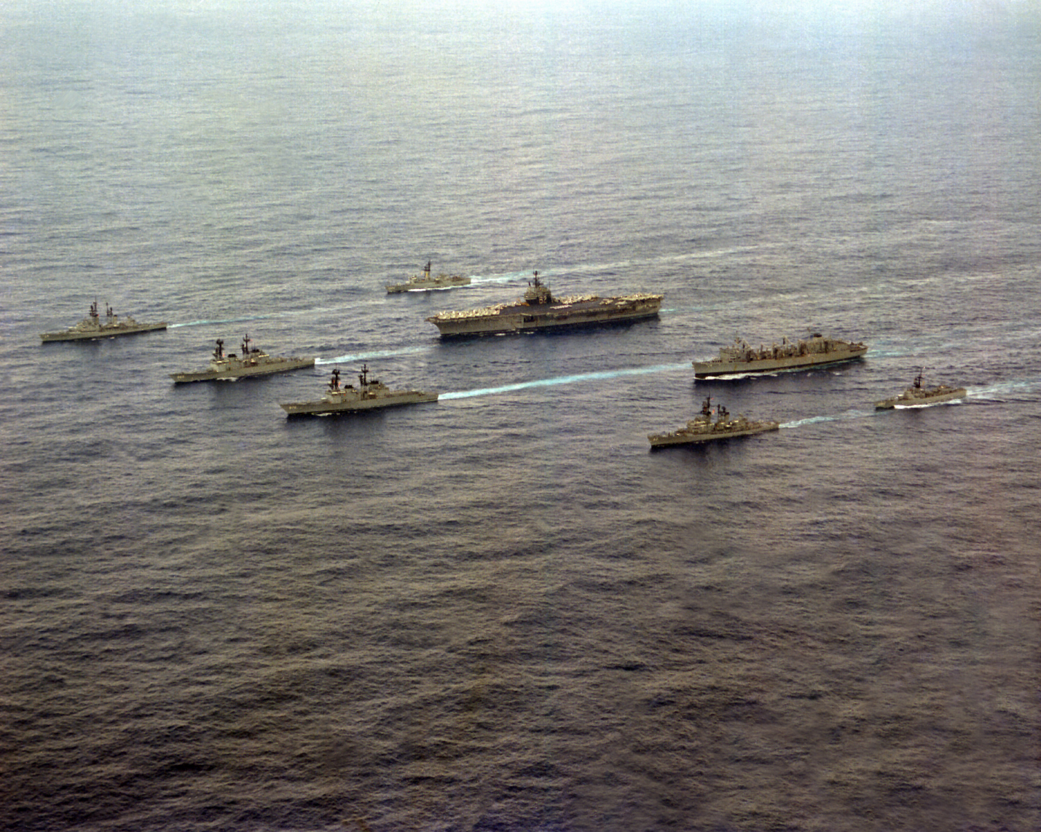

CVBG Independence

* CV-62 Independence (FLAG)
  + CVW 5
    - VF-21 Free Lancers F-14A
    - VF-154 Black Knights F-14A
    - VFA-192 Golden Dragons F/A-18C (N)
    - VFA-195 Dam Busters F/A-18C (N)
    - VA-115 Eagles A-6E SWIP
    - VAQ-136 Gauntlets EA-6B
    - VAW-115 Liberty Bells E-2C
    - VS-21 Redtails S-3B
    - HS-12 Wyverns SH-3H
    - VQ-5(El) Sea Shadows ES-3A
  + CG-16 Leahy
  + CG-52 Bunker Hill (in port at war start)
  + CGN-36 California
  + DD-975 O'Brien
  + DDG-994 Callaghan (in port at war start)
  + FFG-48 Vandegrift